Basic Two-Router Network - Static Routing Topology

Ping/Connectivity Testing

The test confirmed successful communication between
hosts in network 192.168.1.0/24
hosts in network 192.168.2.0/24.

Ping results for Network 1 (192.168.1.0/24):
Device | Results
PC1 | 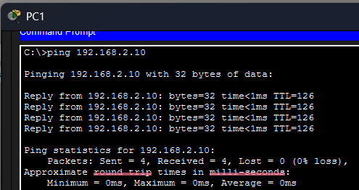
PC2
PC3
PC4
PC5

Router-to-Router Network (10.10.10.0/30):
Device | Results
From R1 to R2 | 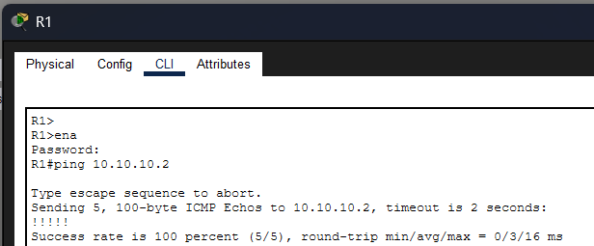
From R2 to R1 | 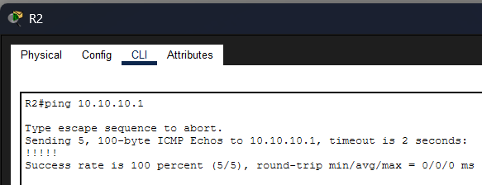

Network 2 (192.168.2.0/24):
Device | Results
PC1 | 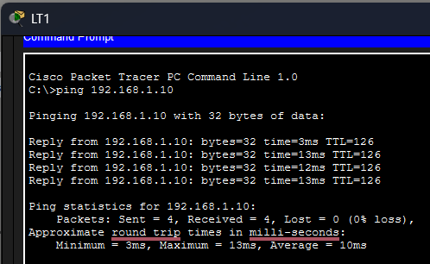
PC2
PC3
PC4
PC5

